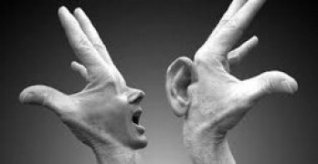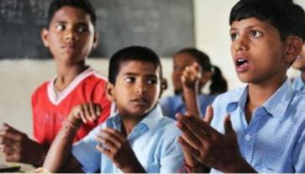

To develop some other apps, like Google live,Transcribe(ANDROID) To connect (iOS) ,

A val iOS to deaf peoples.

To develop some other APP2speak is a complete solution for any one how has difficulty speaking in dumb peoples.

**What do they THINK and FEEL?**

**GOAL**

**PAINS**

What are their fears, frustrations, and anxieties?

**GAINS**

# What are their wants, needs, hopes, and dreams?

**Need some inspiration?**

1.despite the increasing attention given to pain ,little is known about how deaf people communicate their pain and which scale they prefer to use.

See a finished version of this template to kickstart your work.

**[Open example](https://app.mural.co/template/018339d6-ff71-42d8-9e5c-abddde77d5ab/982236e0-c7e5-4fb6-83e9-ef1b972b25bd)**

**What do they DO?**

1.What behavior have we observed?

# What other thoughts and feelings might influence their behavior?

**What do they**

**SAY?**

* 1. What have we heard them say? 2.What can we imagine them saying?

1.For some deaf people,passing behaviour are driven by type of attitudes they have about caring people.

Deaf and dumb people use sign language to express their thoughts &ideas.

Feelings many researches were done on deaf & dumb people about their physical health causes deafness,& degree of hearing loss.

1.Deaf when taking about people with hearing lose, in general some of us an hear quit a bit.

we hard of hearing people.

2.God hears no more than the heart speaks,and if the heart be dumb, god will certainly be deaf.